1. STOP SECONDARY DB

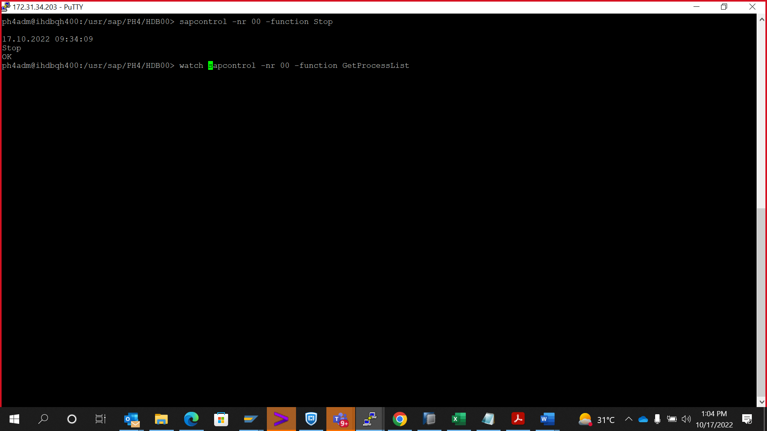

1. STOP REPLICATION IN SECONDARY

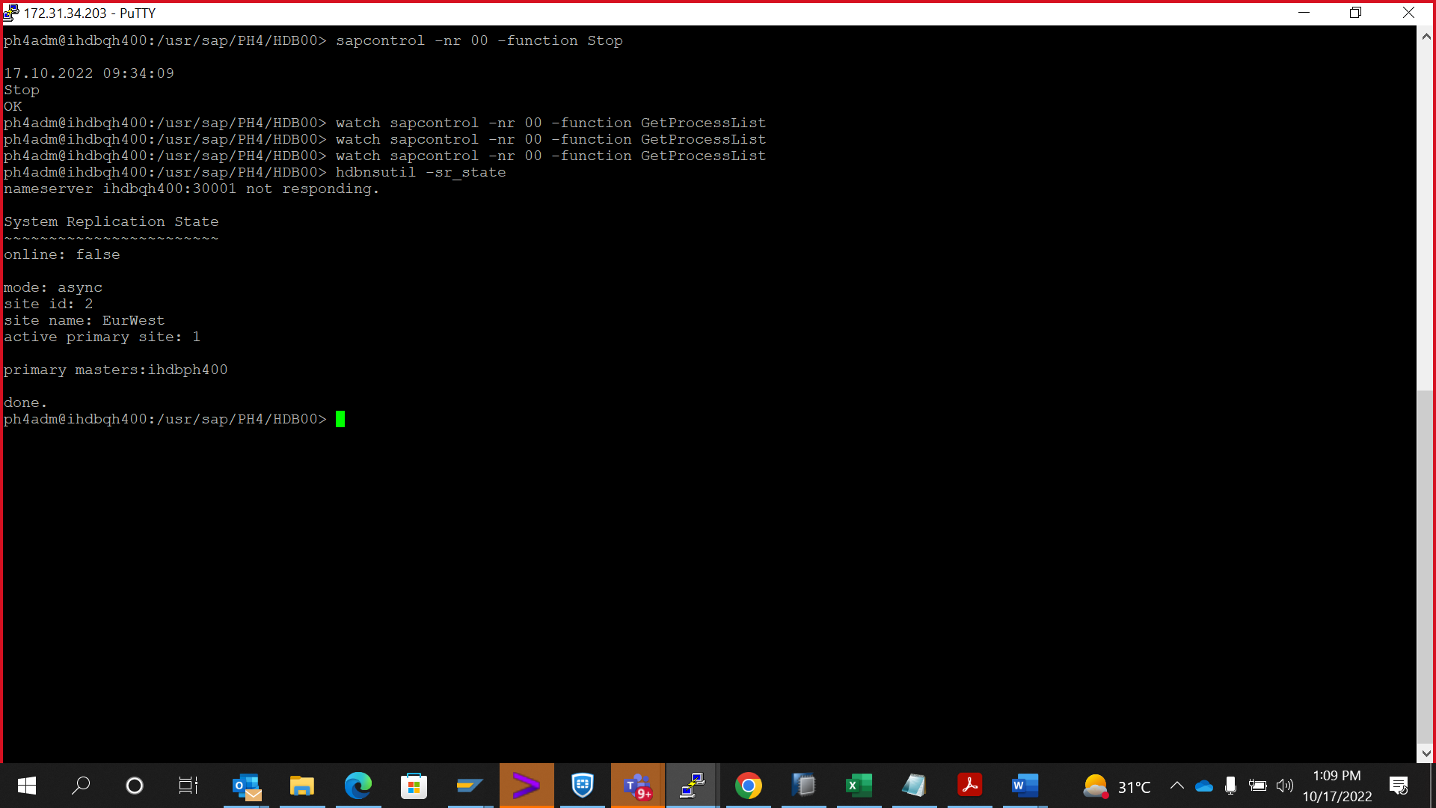

To check the state – hdbnsutil -sr_state

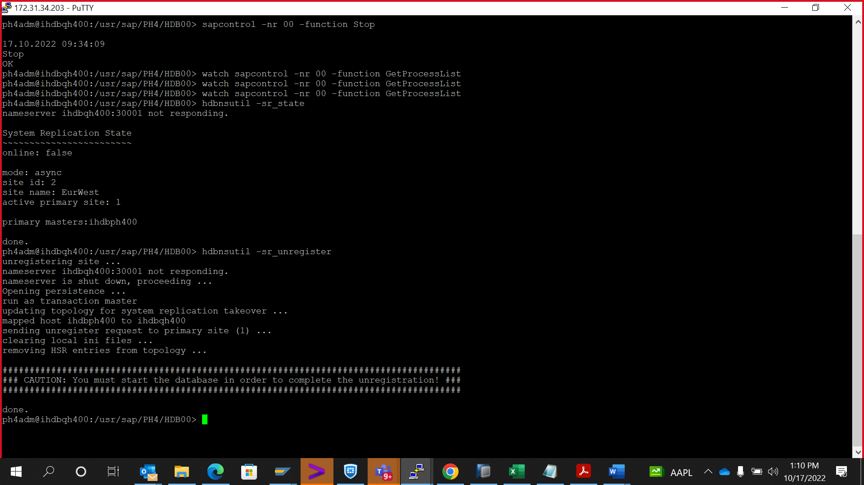

Hdbnsutil -sr_unregister

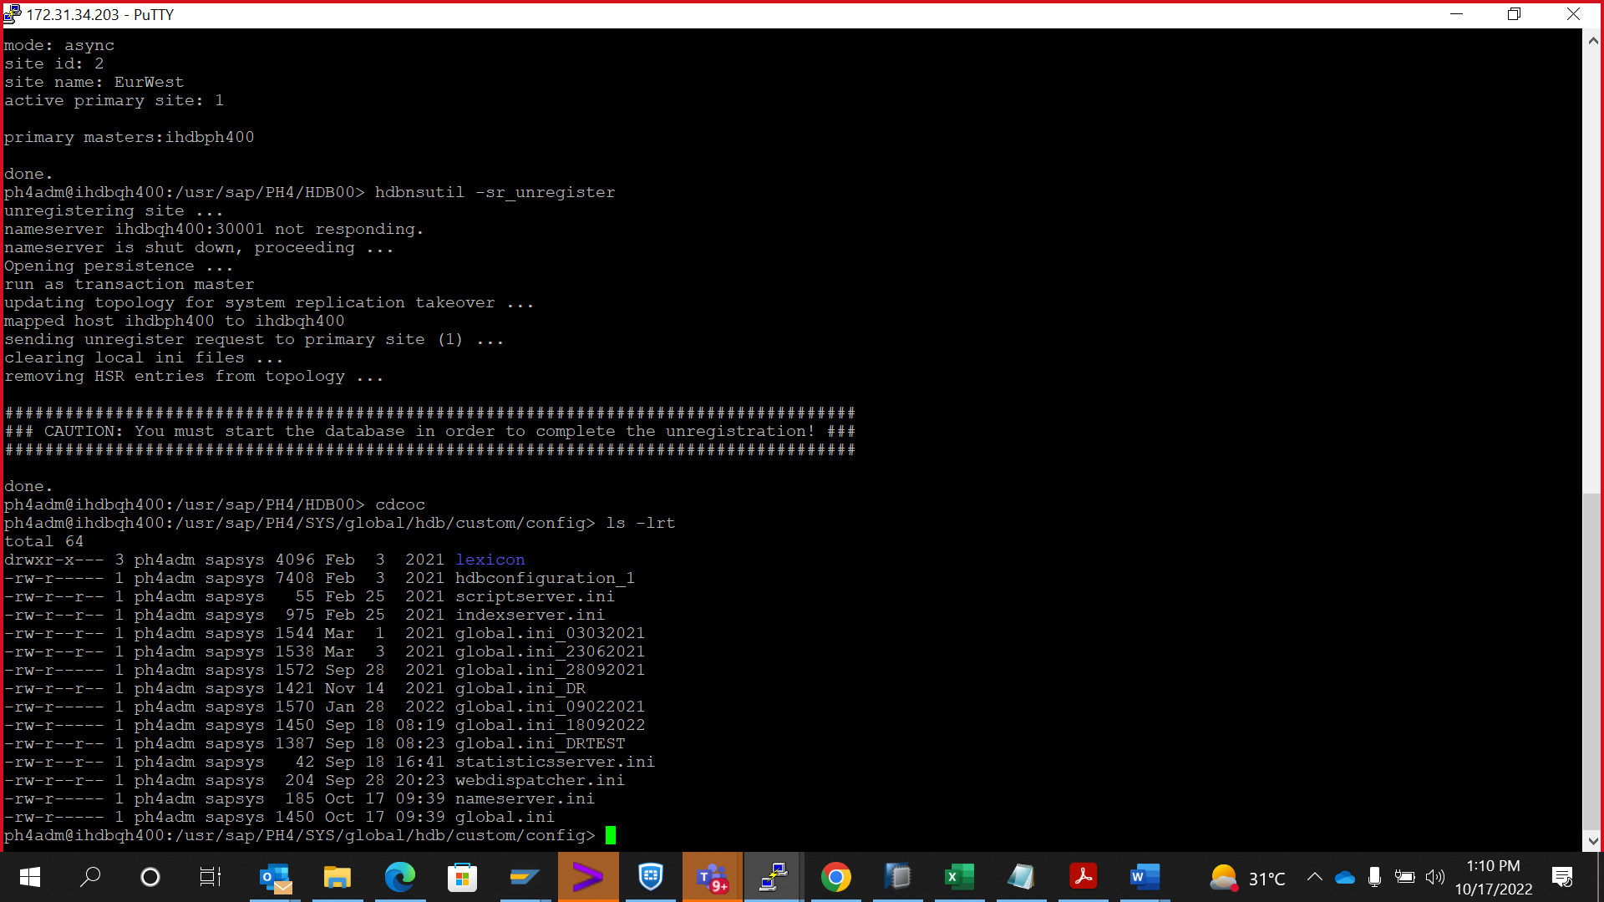

Cdcoc – global.ini

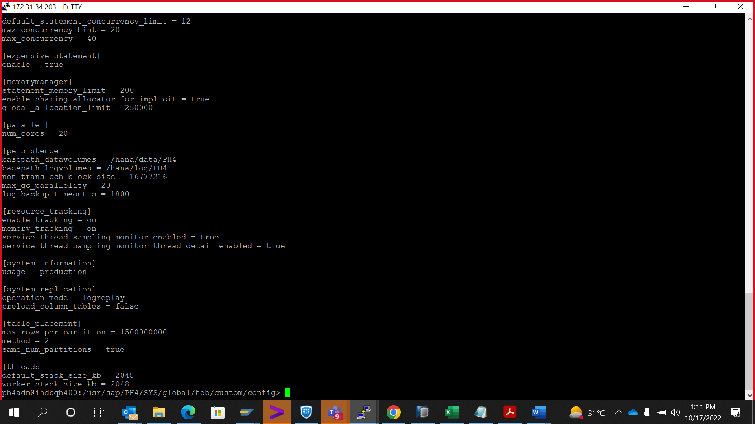

Hash the # global_allocation_limit = 250000

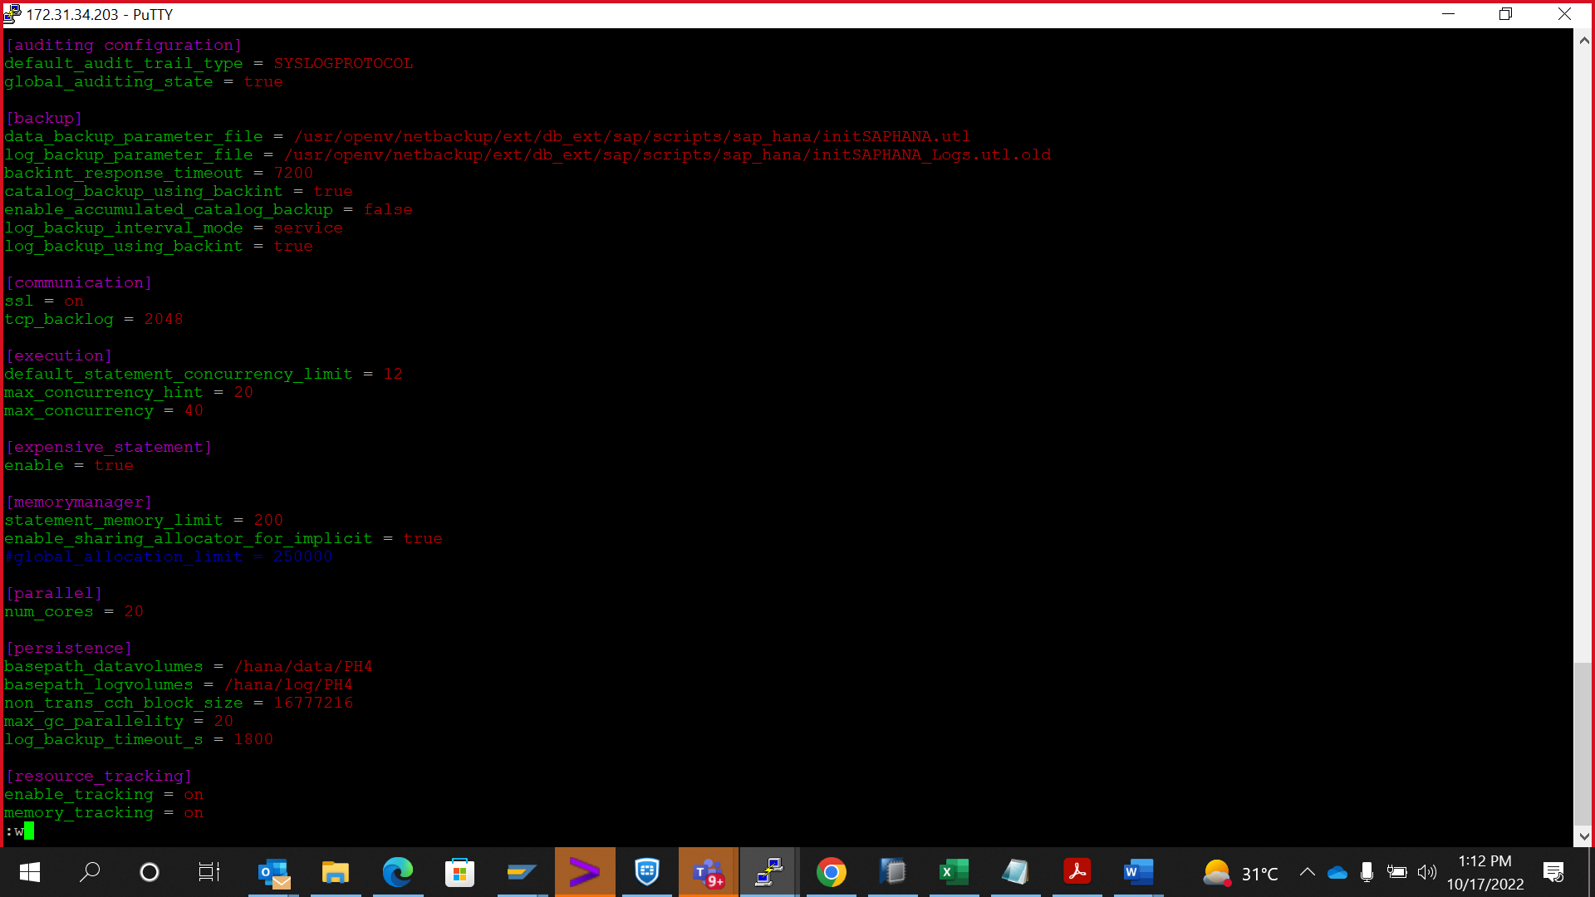

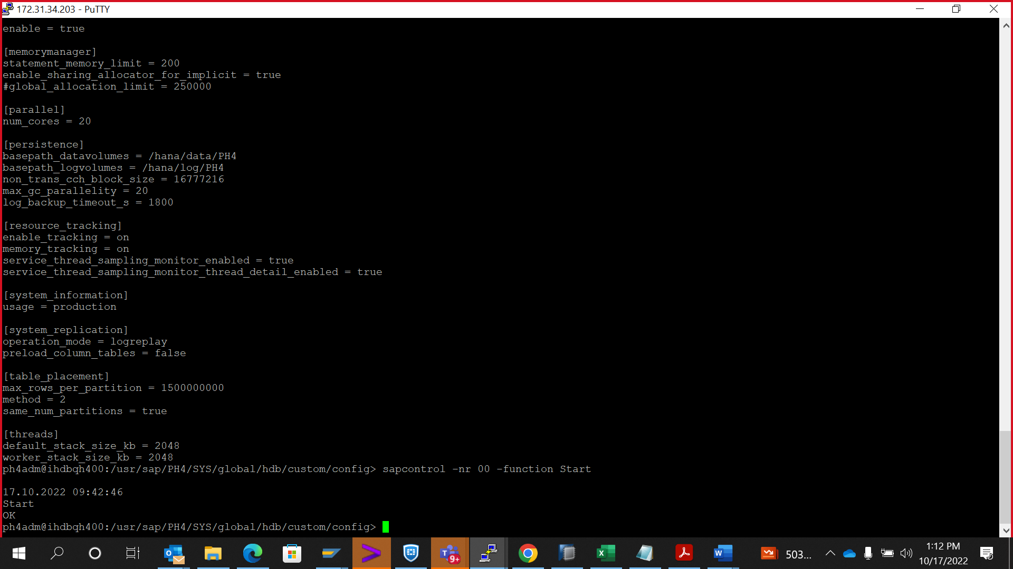

Started the secondary DB and then revert back the parameter global_allocation_limit

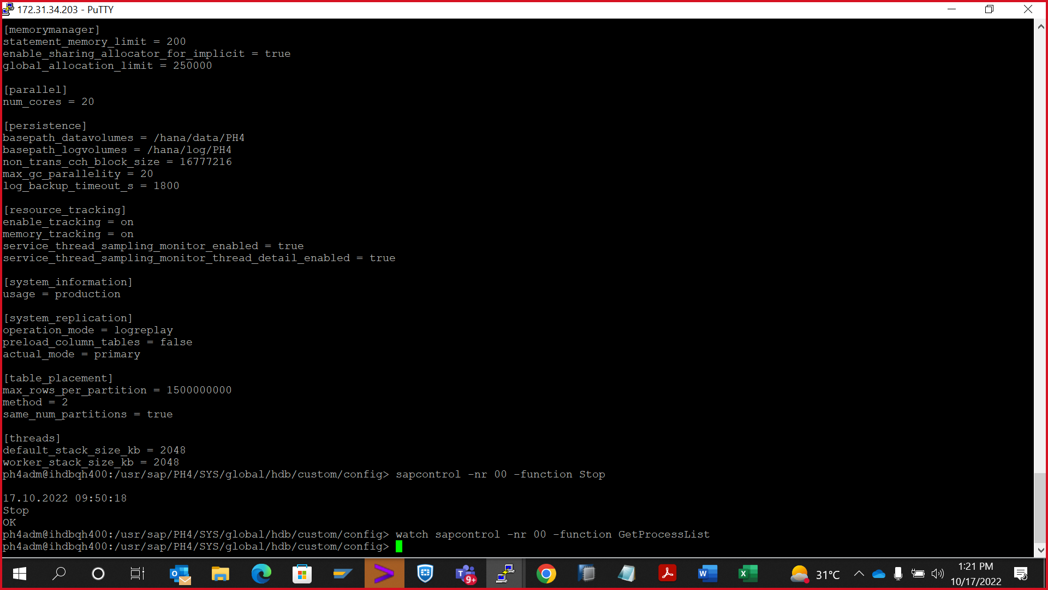

Stop the secondary db again

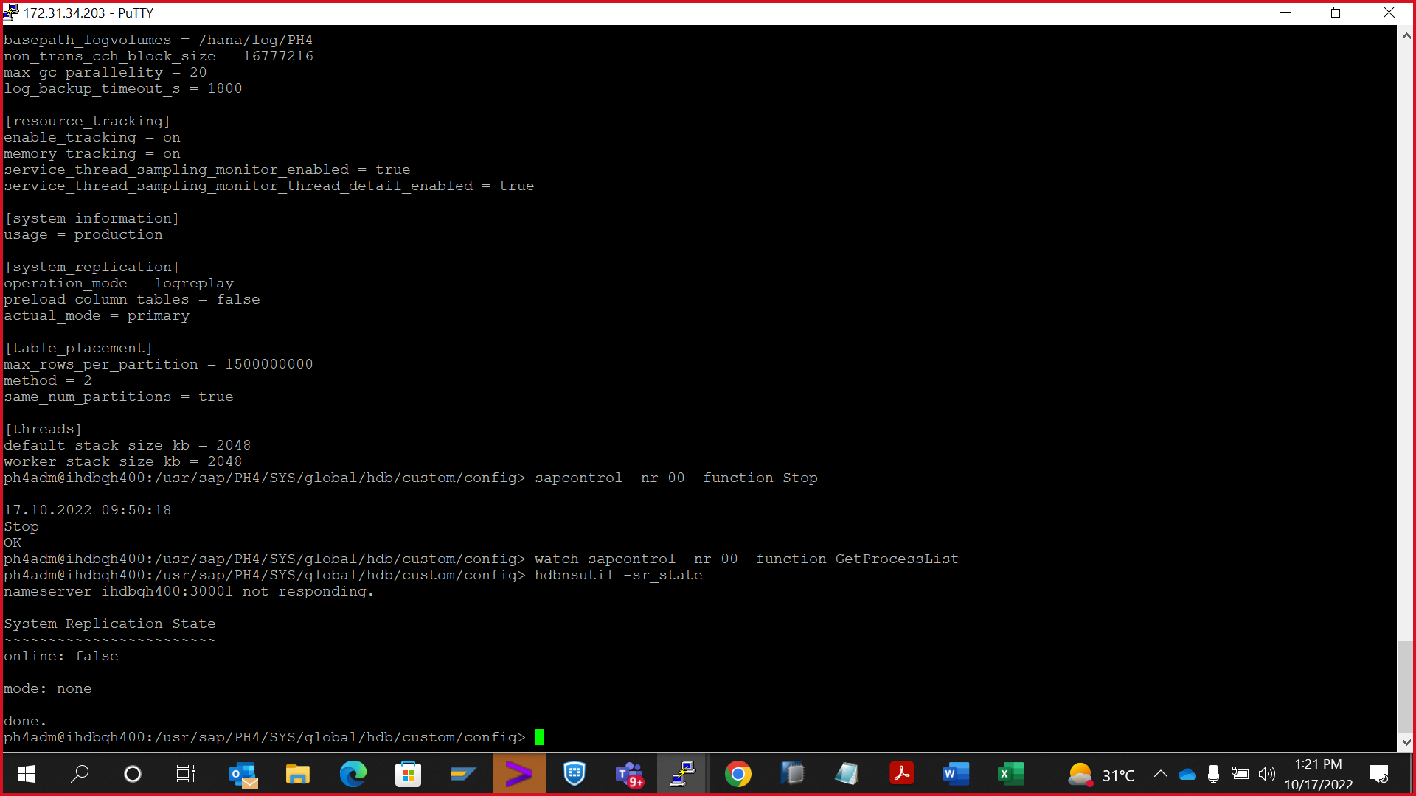

Hdbnsutil -sr_state

Take a full db backup in azure

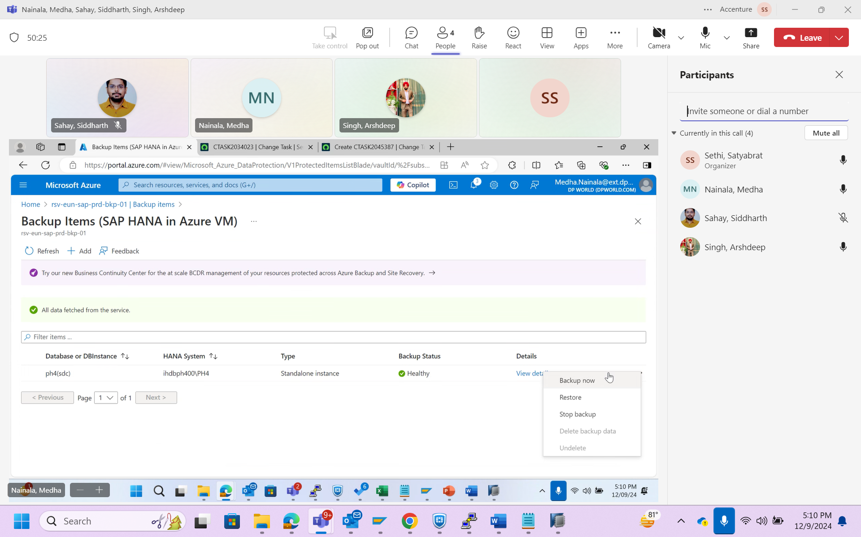

Reclaim log in primary, it will be automatically replicated in secondary 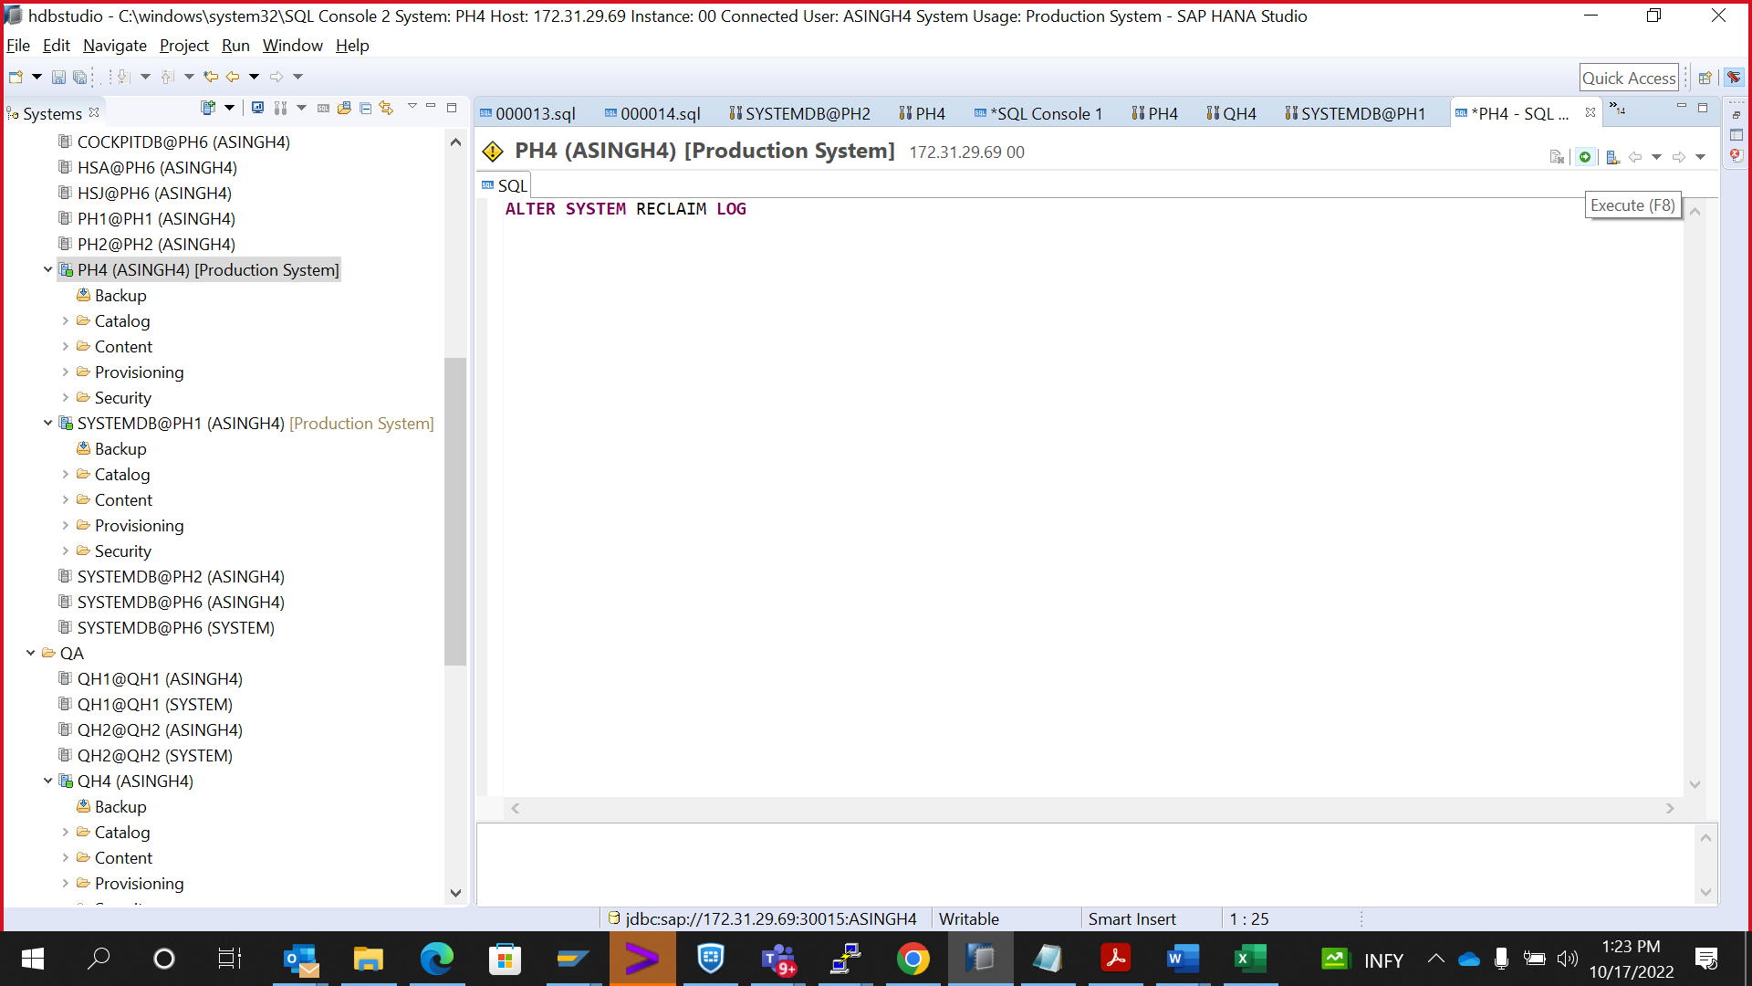

ALTER SYSTEM RECLAIM LOG

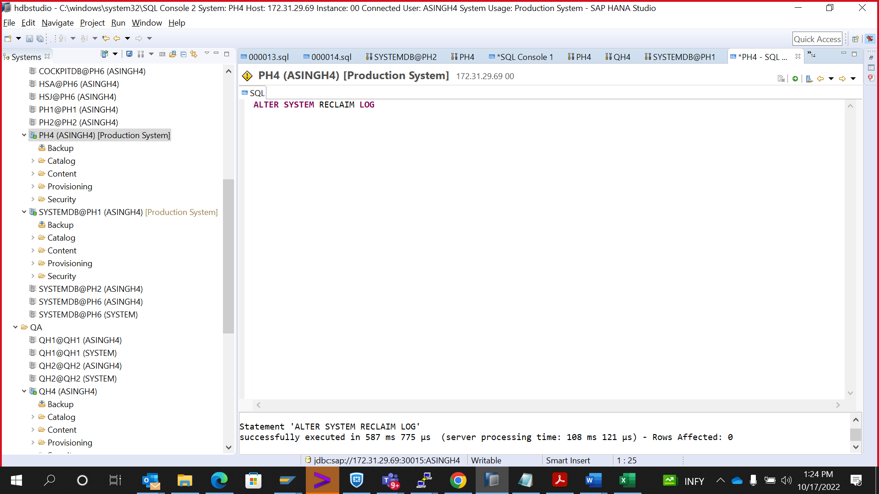

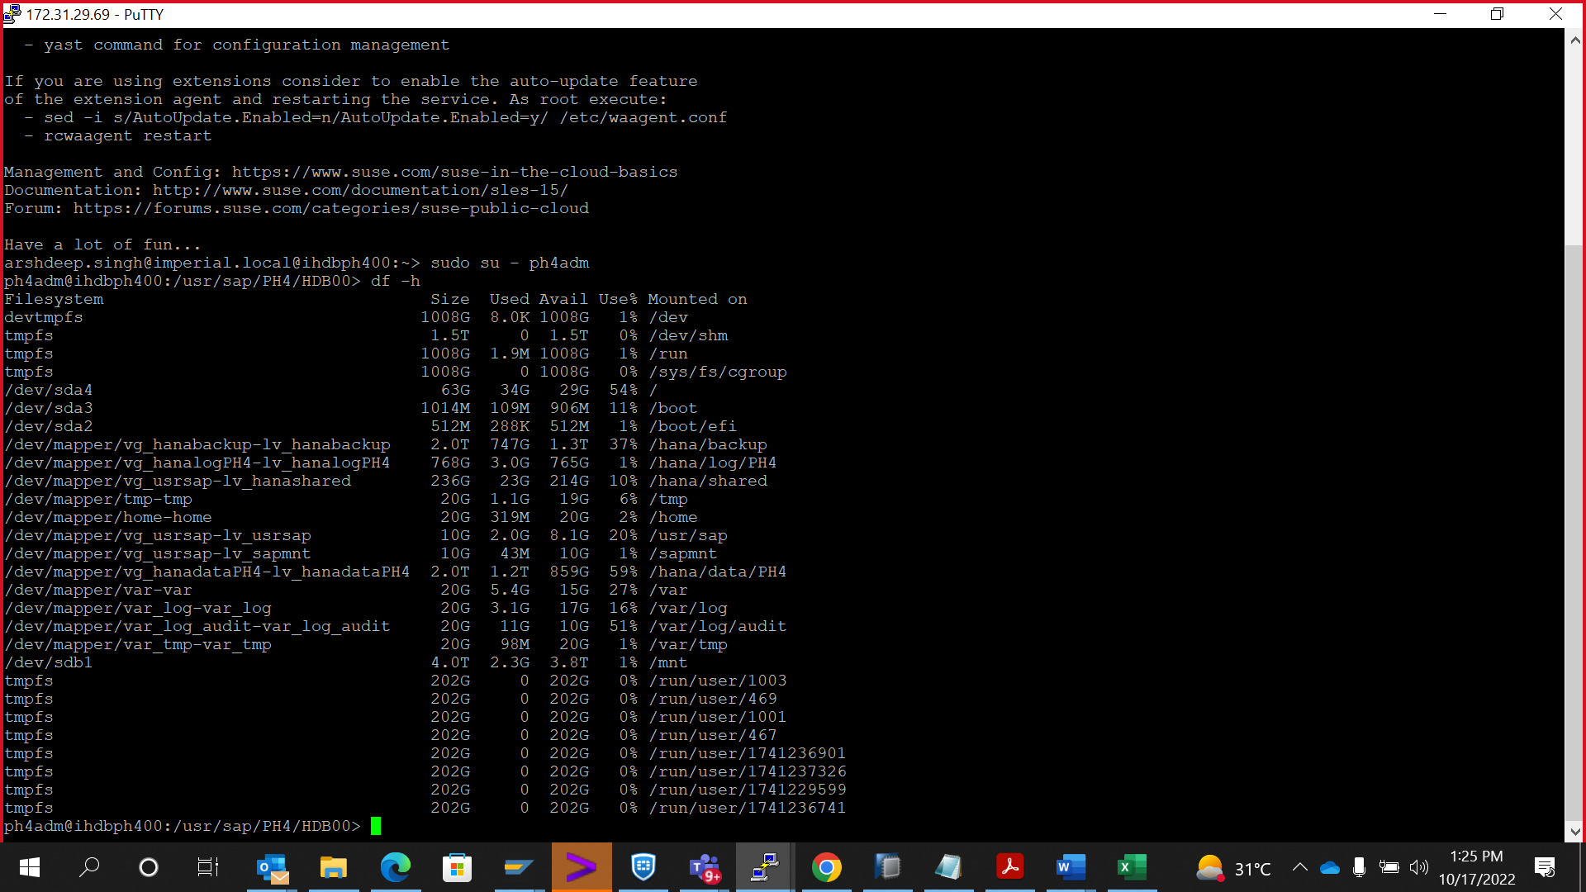

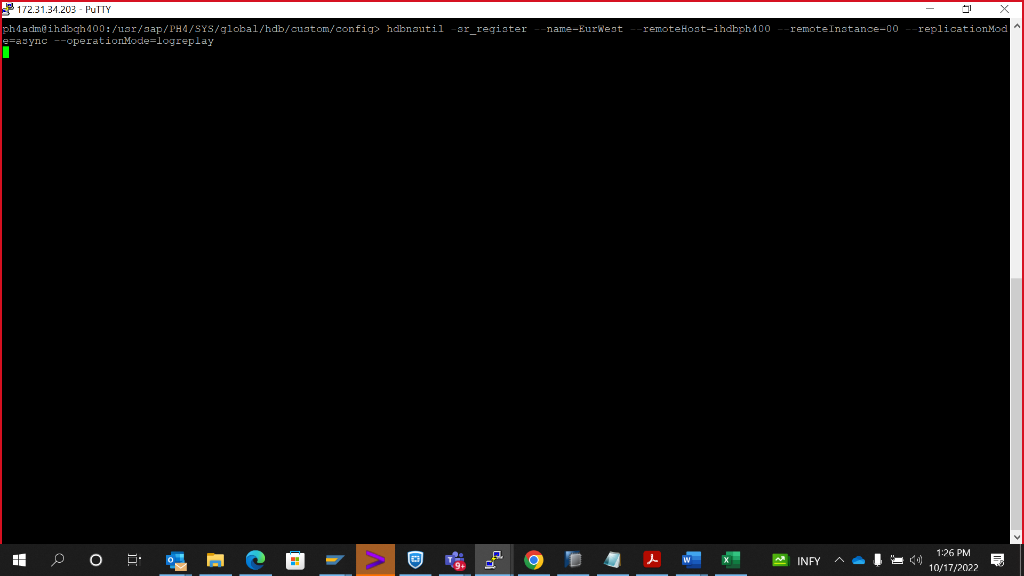

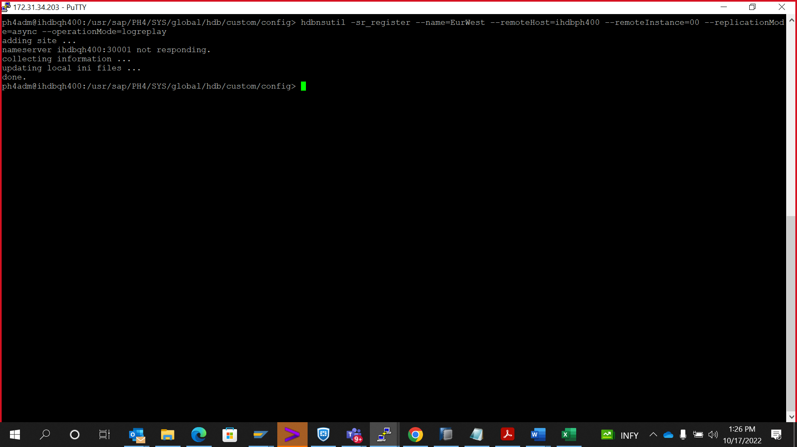

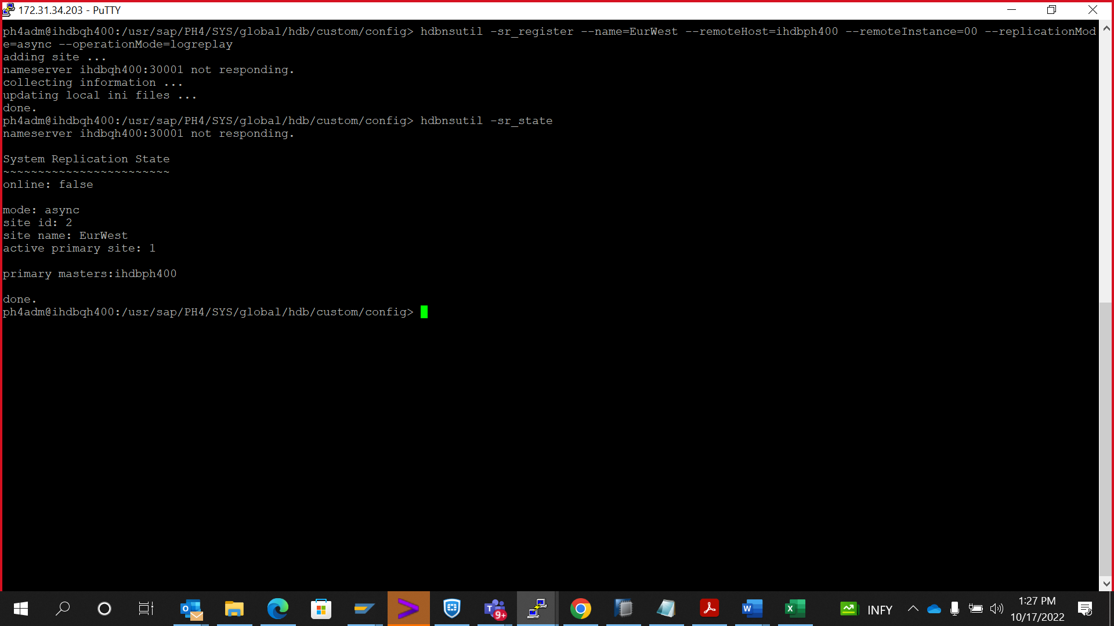

Start the secondary DB

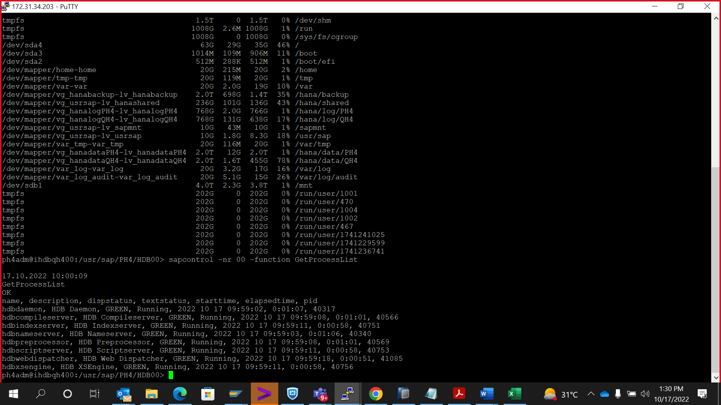

hdbnsutil -sr_unregister

hdbnsutil -sr_state

hdbcons -e hdbindexserver "replication info"

hdbnsutil -sr_register --name=EurWest --remoteHost=ihdbph400 --remoteInstance=00 --replicationMode=async --operationMode=logreplay

hdbnsutil -sr_enable --name=ihdbph400

## hdbnsutil -sr_disable

**********************************************************

ALTER SYSTEM RECLAIM LOG

